
សាកលវិទ្យាល័យភូមិន្ទភ្នំពេញ
ROYAL UNIVERSITY OF PHNOM PENH

ប្រធានបទរបាយការណ៍ស្រាវជ្រាវ
Explainable AI for Diabetes Risk Prediction and Actionable Insights

A Final Report
In Partial Fulfilment of the Requirement for the Degree of
Bachelor of Engineering in Data Science and Engineering

NHOR POVKETYA

June 2026
សាកលវិទ្យាល័យភូមិន្ទភ្នំពេញ
ROYAL UNIVERSITY OF PHNOM PENH

ប្រធានបទនិរបាយការណ៍ស្រាវជ្រាវ
Explainable AI for Diabetes Risk Prediction and Actionable Insights

A Final Report
In Partial Fulfilment of the Requirement for the Degree of
Bachelor of Engineering in Data Science and Engineering

NHOR POVKETYA

Examination committee: Dr. Khim Chamroeun (Chairperson)
Dr. Mao Makara
Mr. Chap Chanpiseth

June 2026

Abstract in Khmer

ជំងឺទឹកនោមផ្អែម គឺជាបញ្ហាប្រឈមផ្នែកសុខភាពសាធារណៈដ៏ធំមួយនៅកម្ពុជា ដែលទាមទារឱ្យមានការពិនិត្យស្វែងរកហានិភ័យតាំងពីដំបូង ដើម្បីទប់ស្កាត់ផលវិបាកធ្ងន់ធ្ងរ។ ទោះជាយ៉ាងណា ប្រទេសកម្ពុជានៅខ្វះខាតឧបករណ៍ព្យាករណ៍ (Predictive Tools) ដោយសារទិន្នន័យសុខភាពក្នុងស្រុកនៅមានកម្រិតតិចតួច។ ដើម្បីដោះស្រាយបញ្ហានេះ ការសិក្សានេះបានបង្កើត និងវាយតម្លៃប្រព័ន្ធ Machine Learning (ML) សម្រាប់ព្យាករណ៍ហានិភ័យជំងឺទឹកនោមផ្អែម ដោយប្រើបច្ចេកទេសផ្ទេរទិន្នន័យ (Cross-dataset transfer) ពីសំណុំទិន្នន័យសុខភាពសាធារណៈដ៏ធំរបស់អាមេរិកគឺ BRFSS ឆ្នាំ២០១៧ (សម្រាប់ធ្វើ Training និង Internal Validation) មកអនុវត្តលើគំរូប្រជាជនកម្ពុជា តាមរយៈសំណុំទិន្នន័យ Cambodia STEPS ដែលមានកំណត់ត្រាអាចប្រើប្រាស់បានចំនួន ៨៧៣ បន្ទាប់ពីការសម្អាតទិន្នន័យ និងការតម្រឹមលក្ខណៈពិសេស (សម្រាប់ធ្វើ Test Set)។ សំណុំទិន្នន័យទាំងពីរត្រូវបានតម្រឹមឱ្យនៅសល់លក្ខណៈសម្បត្តិរួមគ្នាចំនួន ១១ Features ដែលជាប្រភេទ Non-invasive (មិនរាតត្បាតរាងកាយ) រួមមានព័ត៌មានប្រជាសាស្ត្រ (Demographics) ស្ថានភាពសុខភាព និងទម្លាប់រស់នៅ។ នៅក្នុងដំណើរការរៀបចំទិន្នន័យ ទិន្នន័យ BRFSS ត្រូវបានបែងចែកជា Training Set ៨០% និង Validation Set ២០% តាមវិធីសាស្ត្រ Stratified Splitting ហើយបច្ចេកទេស SMOTETomek ត្រូវបានយកមកប្រើប្រាស់តែនៅលើ Training Set ប៉ុណ្ណោះ ដើម្បីដោះស្រាយបញ្ហាអតុល្យភាពទិន្នន័យ (Class Imbalance) ដោយរក្សាទុក Validation និង Test Set ឱ្យនៅដដែលដើម្បីជៀសវាងបញ្ហា Data Leakage។

នៅក្នុងការសិក្សានេះ ម៉ូដែល Machine Learning ចំនួន ៥ ត្រូវបានយកមកបណ្តុះបណ្តាល រួមមាន Logistic Regression, Random Forest, XGBoost, LightGBM, និង CatBoost។ ក្នុងនោះ ម៉ូដែលដែលខ្លាំងជាងគេចំនួន ៣ គឺ XGBoost, Logistic Regression, និង CatBoost ត្រូវបានរួមបញ្ចូលគ្នាជាម៉ូដែលរួមមួយហៅថា Soft Voting Ensemble។ យើងបានជ្រើសរើសយកកម្រិតចាត់ថ្នាក់ (Classification Threshold) ស្មើនឹង 0.43 ដោយផ្អែកលើការផ្ទៀងផ្ទាត់ F1-score និងលក្ខខណ្ឌតម្រូវឱ្យម៉ូដែលដឹងពីអ្នកជំងឺពិតប្រាកដយ៉ាងហោចណាស់ ៧០% (Recall >= 70%)។ ជាលទ្ធផលនៅលើសំណុំទិន្នន័យតេស្តឯករាជ្យ Cambodia STEPS ម៉ូដែល Soft Voting Ensemble នេះសម្រេចបានអត្រារកឃើញអ្នកជំងឺពិត (Recall) 76.23%, ភាពត្រឹមត្រូវនៃការព្យាករណ៍ (Precision) 20.58%, ភាពត្រឹមត្រូវសរុប (Accuracy) 55.56%, និងទទួលបាន F1-score 32.40%។ លទ្ធផលទាំងនេះបង្ហាញថា ម៉ូដែលដែលបានស្នើឡើងមានសមត្ថភាពខ្ពស់ក្នុងការស្វែងរកករណីជំងឺទឹកនោមផ្អែមភាគច្រើននៅក្នុងប្រជាជនកម្ពុជា ប៉ុន្តែវាក៏បង្កើតលទ្ធផលវិជ្ជមានក្លែងក្លាយច្រើនផងដែរ (High False Positives) ដែលនេះបណ្តាលមកពីភាពខុសគ្នានៃទម្រង់ប្រជាជន (Population Characteristics) រវាងសហរដ្ឋអាមេរិក និងកម្ពុជា។

ដើម្បីគាំទ្រដល់ការបកស្រាយលទ្ធផលរបស់ម៉ូដែល ប្រព័ន្ធ SHAP ត្រូវបានយកមកប្រើប្រាស់ជាបច្ចេកទេសបំពេញបន្ថែម ជាមួយ XGBoost ក្នុងនាមជា Tree-based Proxy Model ដើម្បីបង្ហាញពីកត្តាហានិភ័យទាំងកម្រិតរួម (Global) និងកម្រិតបុគ្គល (Patient-level) ដែលក្នុងនោះកត្តាហានិភ័យចម្បងៗរួមមាន BMI, ជំងឺលើសឈាម (High Blood Pressure), កូលេស្តេរ៉ុលខ្ពស់ (High Cholesterol), អាយុ, និងសកម្មភាពរាងកាយ (Physical Activity)។ ប្រព័ន្ធចុងក្រោយនេះត្រូវបានដាក់ឱ្យដំណើរការនៅលើផ្ទាំងកម្មវិធី Streamlit Web Dashboard ដែលអាចបង្ហាញកម្រិតហានិភ័យ លទ្ធផលពន្យល់ពី SHAP និងផ្តល់ការណែនាំអំពីការកែប្រែរបៀបរស់នៅ (Lifestyle Recommendations) ដែលអាចអនុវត្តបាន។ ជាសន្និដ្ឋាន ការសិក្សានេះបង្ហាញថា ម៉ូដែល Machine Learning ដែលផ្តោតលើ Recall និងអាចពន្យល់លទ្ធផលបាន អាចជួយគាំទ្រដល់ការពិនិត្យហានិភ័យជំងឺទឹកនោមផ្អែមតាំងពីដំបូងបានយ៉ាងល្អ ប៉ុន្តែវាគួរតែត្រូវបានប្រើប្រាស់ត្រឹមជាឧបករណ៍ជួយពិនិត្យស្រាវជ្រាវបឋម (Screening Support Tool) ប៉ុណ្ណោះ មិនមែនជាប្រព័ន្ធវិនិច្ឆ័យរោគផ្លូវការ (Medical Diagnosis System) ជំនួសគ្រូពេទ្យឡើយ។

Abstract in English

Diabetes mellitus is a growing public health burden in Cambodia, where early screening is essential for reducing severe and costly complications. However, the development of local diabetes risk-prediction tools is constrained by the limited availability of large, labelled Cambodian health-survey data. This study addresses this gap by developing and independently evaluating a machine learning system for diabetes risk prediction based on non-invasive, survey-based health indicators, using a cross-population transfer strategy from a large international survey to a Cambodian population sample.
The Behavioral Risk Factor Surveillance System (BRFSS) 2017 dataset was used for model development and internal validation, while the Cambodia STEPS dataset, comprising 873 usable records after preprocessing and feature alignment, was reserved exclusively as an independent external test set. Both datasets were harmonised into eleven shared non-invasive features spanning demographic, health-status, and lifestyle variables. The BRFSS data were partitioned into 80% training and 20% validation using stratified sampling, and SMOTETomek was applied only to the training set to address class imbalance, leaving the validation and test sets untouched to prevent data leakage.
Five machine learning models were developed and compared: Logistic Regression, Random Forest, XGBoost, LightGBM, and CatBoost. The three strongest models, XGBoost, Logistic Regression, and CatBoost, were combined into a Soft Voting ensemble. The final model and its classification threshold were selected using the validation F1-score subject to a minimum diabetes recall of 70%, which yielded a threshold of 0.43. On the independent Cambodia STEPS test set, the ensemble achieved 76.23% recall, 20.58% precision, 55.56% accuracy, and an F1-score of 32.40%.
These results indicate that the model can correctly identify most diabetes cases in a previously unseen Cambodian population, although it also produces a substantial number of false positives, reflecting cross-population differences between the United States and Cambodia. To support interpretation, SHAP (SHapley Additive exPlanations) was applied with XGBoost as a tree-based proxy model, identifying body mass index, high blood pressure, high cholesterol, age, and physical activity as the most influential risk factors at both the global and individual levels. The complete system was deployed as a Streamlit dashboard that reports risk tiers, model explanations, and actionable lifestyle recommendations. Overall, this study demonstrates that a recall-oriented, cross-population machine learning model can support early diabetes risk screening in a low-resource setting, provided that it is used as a screening-support tool rather than a substitute for medical diagnosis.

SUPERVISOR’S RESEARCH SUPERVISION STATEMENT

TO WHOM IT MAY CONCERN

Name of program: Bachelor of Engineering in Data Science and Engineering
Name of candidate: Nhor Povketya

Title of research report: Explainable AI for Diabetes Risk Prediction and Actionable Insights

This is to certify that the research carried out for the above titled Bachelor’s research report was completed by the above-named candidate under my direct supervision. This thesis material has not been used for any other degree. I played the following part in the preparation of this research report: ………………………………………………………….
…………………………………………………………...................................................................................................................................................................................................................................................................................................................................................................................................................................................

Supervisor's name: Dr. Khim Chamroeun

Supervisor’s signature:…………………….

Date……………………………………………

CANDIDATE’S STATEMENT

TO WHOM IT MAY CONCERN

This is to certify that the research report that I, Nhor Povketya, hereby present entitled: Explainable AI for Diabetes Risk Prediction and Actionable Insights for the degree of Bachelor of Engineering at the Royal University of Phnom Penh is entirely my own work and, furthermore, that it has not been used to fulfil the requirements of any other qualification in whole or in part, at this or any other University or equivalent institution.

No reference to, or quotation from, this document may be made without the written approval of the author.

Signed by Nhor Povketya: …………………………

Date: ……………………………………………….

Sign by Supervisor: Dr. Khim Chamroeun

Supervisor’s signature: ………………………...…

Date…………………………………………….…

Acknowledgements

With sincere appreciation, I would like to express my deepest gratitude to my supervisor, Dr. Khim Chamroeun, for his valuable guidance, patience, encouragement, and constructive feedback throughout the completion of this research. His knowledge and advice have greatly helped me improve the quality of this study and shaped the direction of my work in machine learning, explainable artificial intelligence, and public health research.
I would also like to sincerely thank the Royal University of Phnom Penh, especially the Department of Data Science and Engineering, for providing me with the academic foundation, learning environment, and support needed to complete this final year research project. The knowledge and skills I have gained throughout my studies have been very important in carrying out this work.
I am also grateful to the Centers for Disease Control and Prevention (CDC) for making the BRFSS dataset publicly available. I would like to extend my appreciation to the World Health Organization (WHO) and the Ministry of Health of Cambodia for providing access to the Cambodia STEPS survey data for academic research. These data sources were essential for conducting this study.

Finally, I would like to give my deepest thanks to my family and friends for their love, encouragement, and support throughout this journey. Their understanding and motivation helped me continue working even during difficult times.

Table of Contents
Abstract in Khmer iii
Abstract in English v
SUPERVISOR’S RESEARCH SUPERVISION STATEMENT vi
CANDIDATE’S STATEMENT viii
Acknowledgements ix
LIST OF TABLES xiii
LIST OF FIGURES xiv
LIST OF ABBREVIATIONS xv
CHAPTER 1 INTRODUCTION 1
1.1 Background to the Study 1
1.2 Problem Statement 2
1.3 Aim, Objectives, and Research Questions 2
1.4 Rationale of the Study 3
1.5 Scope and Limitations 4
1.6 Structure of the Study 5
CHAPTER 2 LITERATURE REVIEW 6
2.1 Diabetes Risk Prediction Using Survey Data 6
2.2 Machine Learning Models for Diabetes Prediction 6
2.3 Class Imbalance and Resampling 7
2.4 The Importance of Recall in Screening 7
2.5 Model Interpretation and SHAP in Healthcare 8
2.6 Cross-Population Generalization 8
2.7 Research Gap and Contribution 9
CHAPTER 3 METHODOLOGY AND TOOLS 10
3.1 Research Design 10
3.2 Tools and Technologies Used 10
3.2.1 Python and Visual Studio Code 11
3.2.2 pandas, NumPy, and Matplotlib 11
3.2.3 scikit-learn 11
3.2.4 XGBoost, LightGBM, and CatBoost 11
3.2.5 imbalanced-learn (SMOTETomek) 11
3.2.6 SHAP 11
3.2.7 Streamlit and the Gemini API 11
3.3 Data Sources 12
3.3.1 BRFSS 2017 (Training and Validation) 12
3.3.2 Cambodia STEPS (Independent Test) 12
3.4 Data Preparation and Feature Alignment 12
3.5 Feature Engineering and Imbalance Handling 13
3.5.1 Standardisation 13
3.5.2 SMOTETomek and Data Leakage 13
3.6 Models Used 13
3.6.1 Logistic Regression 14
3.6.2 Random Forest 14
3.6.3 XGBoost 14
3.6.4 LightGBM 14
3.6.5 CatBoost 14
3.7 Soft Voting Ensemble 14
3.8 Threshold Tuning 14
3.9 Evaluation Metrics 15
3.9.1 Confusion Matrix 15
3.9.2 Accuracy, Precision, Recall, and F1-Score 16
3.9.3 ROC Curve and AUC 16
3.10 Explainability Method 16
CHAPTER 4 RESULTS 18
4.1 Experimental Setup 18
4.2 Data Distribution 18
4.3 Data Splits 18
4.4 Class Balancing with SMOTETomek 19
4.5 Validation Results of Individual Models 20
4.6 Final Model and Threshold Selection 21
4.7 Risk Tiers and the Classification Threshold 22
4.8 Independent Test on Cambodia STEPS 23
4.9 Validation vs Test Comparison 24
4.10 Explainability Results 25
4.11 Patient Dashboard and Actionable Insights 27
CHAPTER 5 DISCUSSION 29
5.1 Overview 29
5.2 Effectiveness of the Models 29
5.3 The Cross-Population Gap 29
5.4 Value of Explainability and the Dashboard 30
5.5 Challenges and Findings 30
5.6 Threats to Validity 31
5.7 Ethical Considerations 32
CHAPTER 6 CONCLUSION 33
6.1 Summary of Findings 33
6.2 Future Work 33
REFERENCES 35
APPENDICES 37
Appendix A: Deployed Application 37
Appendix B: Source Code and Notebooks 37
Appendix C: Reproducibility 37

LIST OF TABLES
Table 1: Aligned feature set common to BRFSS and STEPS (11 features). 13
Table 2: Class distribution per data split. Cambodia STEPS contains 873 usable records after preprocessing and feature alignment and is used only for the final test. 19
Table 3: Training-set class counts before and after SMOTETomek (validation and test untouched). 19
Table 4: Individual model performance on the BRFSS 2017 validation set (threshold 0.50). 20
Table 5: Validation performance of the selected Soft Voting ensemble at threshold 0.43. 21
Table 6: Risk-tier distribution of the Cambodia STEPS respondents under the Soft Voting model. 23
Table 7: Independent test results on Cambodia STEPS (Soft Voting ensemble, threshold 0.43). 23
Table 8: Validation versus independent-test results for the Soft Voting ensemble. 25

LIST OF FIGURES
Figure 1: Research design and pipeline workflow, from data loading and feature alignment to training, ensemble selection, threshold tuning, independent testing, explainability, and the dashboard. 10
Figure 2: The structure of a confusion matrix, showing true positives, true negatives, false positives, and false negatives. 15
Figure 3: Illustration of an ROC curve and the area under the curve (AUC). 16
Figure 4: Class distribution of BRFSS 2017 (training source) and Cambodia STEPS (independent test). 18
Figure 5: Class distribution across the training, validation, and test splits (log scale, because BRFSS is much larger than STEPS). 19
Figure 6: BRFSS 2017 training set before and after SMOTETomek balancing. 20
Figure 7: Comparison of the five models on the validation set (threshold 0.50). 21
Figure 8: Threshold tuning result on the validation set, showing how recall, precision, F1-score, and accuracy change with the threshold, with the chosen threshold of 0.43 marked. 22
Figure 9: Risk-tier distribution for the Cambodia STEPS test set. 23
Figure 10: Confusion matrix on the Cambodia STEPS test set (Soft Voting, threshold 0.43). 24
Figure 11: Validation versus Cambodia STEPS test results for the Soft Voting ensemble. 25
Figure 12: SHAP global feature importance (mean absolute SHAP value) on the Cambodia STEPS test set, using XGBoost as the tree-based proxy model. 26
Figure 13: SHAP local explanation for a single Cambodia STEPS patient, showing which features increased or decreased the predicted risk. 26
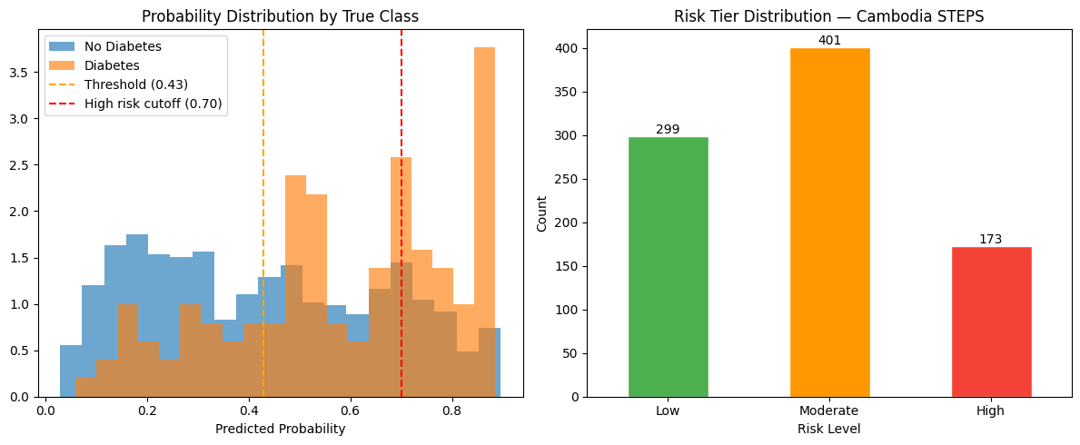Figure 14: Distribution of predicted probabilities on Cambodia STEPS, separated by true class, with the 30% and 70% tier cut-offs marked. 27
Figure 15: Patient dashboard from the deployed application, showing the risk gauge, the main SHAP reasons, the group contributions, and the lifestyle advice. 28

LIST OF ABBREVIATIONS

AUC Area Under the (ROC) Curve
BMI Body Mass Index
BRFSS Behavioral Risk Factor Surveillance System
CatBoost Categorical Boosting
CDC Centers for Disease Control and Prevention
F1 F1-Score (harmonic mean of precision and recall)
LightGBM Light Gradient Boosting Machine
LIME Local Interpretable Model-agnostic Explanations
LR Logistic Regression
ML Machine Learning
NCD Non-Communicable Disease
RF Random Forest
ROC Receiver Operating Characteristic
SHAP SHapley Additive exPlanations
SMOTE Synthetic Minority Oversampling Technique
SMOTETomek SMOTE combined with Tomek-links cleaning
STEPS WHO STEPwise Approach to NCD Risk-Factor Surveillance
WHO World Health Organization
XGBoost Extreme Gradient Boosting

CHAPTER 1
INTRODUCTION

1.1 Background to the Study
Diabetes mellitus is one of the most prevalent chronic non-communicable diseases worldwide. It arises when the body can no longer regulate blood glucose effectively, and, if left uncontrolled, it progressively damages the heart, blood vessels, kidneys, eyes, and nerves. The great majority of cases are type 2 diabetes, which is strongly associated with age, body weight, diet, physical inactivity, and other lifestyle factors [15]. Because many of these factors are modifiable, individuals identified as being at risk at an early stage can take preventive action before the disease progresses to serious and costly complications.
In Cambodia, the prevalence of diabetes has risen steadily alongside rapid urbanisation and dietary change. National surveys conducted under the WHO STEPwise approach to non-communicable disease surveillance (STEPS) indicate that a substantial proportion of Cambodian adults either have diabetes or are at elevated risk, and that a large share of these cases remain undiagnosed [6]. Because screening services are concentrated in a limited number of facilities, many individuals discover the disease only after complications have already developed, when treatment becomes more difficult and more expensive.
Early identification of high-risk individuals is therefore a public-health priority. If people who are likely to have diabetes can be flagged using simple, low-cost information such as age, body mass index, blood-pressure history, and lifestyle habits, they can be referred for confirmatory testing and given timely advice. Machine learning is well suited to this task because it can model the complex, non-linear relationships between many risk factors and disease outcomes, and can produce a risk estimate rapidly and at scale [1].
Two obstacles, however, complicate this approach in Cambodia. The first is data availability: large, well-labelled diabetes datasets are common in high-income countries but scarce in Cambodia, where collecting confirmed labels at scale is costly and slow. The second is trust: a model that outputs only a score, without any indication of why, behaves as a black box, and health workers and patients are unlikely to act on a result they cannot understand. This study responds to both challenges, first by examining whether a model trained on a large foreign survey can transfer to Cambodian data, and second by making the resulting predictions interpretable so that they can be understood and acted upon.

1.2 Problem Statement
The central problem addressed in this study is how to identify individuals at risk of type 2 diabetes in Cambodia in an early, low-cost, and trustworthy manner, given that local labelled data are limited. Assembling a large, clinically confirmed Cambodian dataset would be ideal, but it is expensive and time-consuming, and the resulting sample would still be small relative to the datasets available internationally.
One practical alternative is to train a model on a large foreign dataset, the United States BRFSS survey, which contains hundreds of thousands of labelled records, and to evaluate it on the Cambodian population through the STEPS survey. This raises a question that remains poorly answered in the local context: how well does a diabetes risk model trained on one population perform when applied to a different population, with distinct diets, body composition, and survey methodology? Answering this question honestly requires that the Cambodian data be held out as a genuinely independent test set.
A further challenge is class imbalance. Individuals with diabetes constitute the minority in both surveys, so a naive model that predicts “no diabetes” for everyone would appear accurate yet be clinically useless. In a screening context, a false negative, incorrectly reassuring a person who is genuinely at risk, is more harmful than a false positive, which merely triggers an additional test. Consequently, the model developed in this study is designed to prioritise recall rather than accuracy alone, and to be interpretable so that its outputs can be trusted and acted upon.

1.3 Aim, Objectives, and Research Questions
The aim of this study is to develop and rigorously evaluate a machine learning system for diabetes risk prediction that transfers a model trained on a large foreign health survey to the Cambodian population, prioritising high recall for screening and supporting its predictions with interpretable explanations.
The specific objectives are:
• Objective 1: develop a harmonised, non-invasive feature representation that aligns the BRFSS (United States) and STEPS (Cambodia) surveys into a shared set of low-cost risk factors.
• Objective 2: design a reproducible preprocessing pipeline in which feature scaling and class-imbalance handling are confined to the training data to prevent information leakage.
• Objective 3: develop and compare a range of machine learning models, and combine the strongest performers into an ensemble to improve robustness and generalisation.
• Objective 4: optimise the final model and its decision threshold using validation performance under a recall-oriented selection criterion appropriate for screening, rather than accuracy alone.
• Objective 5: assess the honest cross-population performance of the final model by evaluating it once on the independent Cambodia STEPS dataset, which is excluded from all training and model-selection steps.
• Objective 6: interpret the model's predictions at both the global and individual levels, and present the results through an accessible dashboard that delivers actionable lifestyle insights.
To guide the study, the following research questions were formulated:
• RQ1: How accurately can a machine learning model trained on a large foreign health survey predict type 2 diabetes risk from non-invasive, survey-based indicators?
• RQ2: Which machine learning models, individually or in combination, provide the most suitable balance of recall and overall performance for diabetes screening?
• RQ3: How well does a model trained on the United States BRFSS population generalise to an independent Cambodian population represented by the STEPS survey?
• RQ4: Which health indicators contribute most strongly to the model's diabetes risk predictions?

1.4 Rationale of the Study
This work is motivated by three considerations. First, the burden of undiagnosed diabetes in Cambodia is large and growing, and the cost of late diagnosis, in the form of complications such as kidney failure, blindness, and cardiovascular disease, is severe. A screening tool that relies only on simple, self-reportable information could help extend early risk awareness beyond the limited network of clinics.
Second, the shortage of local labelled data is unlikely to be resolved in the near term, so it is valuable to establish now, and honestly, how far a cross-population transfer approach can go using freely available international data. A transparent benchmark that reports its limitations is more useful to future researchers than an over-optimistic accuracy claim; accordingly, this study reports its weaker metrics alongside its strong recall.
Third, any tool intended for use in health care must be trustworthy. Interpretation methods such as SHAP can reveal which factors raise or lower an individual's predicted risk. Building interpretability into the pipeline from the outset, rather than appending it as an afterthought, is what distinguishes a purely experimental model from a tool that a health worker or patient could realistically use.

1.5 Scope and Limitations
This study focuses on non-invasive, survey-based screening for type 2 diabetes risk; it does not attempt to provide a medical diagnosis. A confirmed diagnosis of diabetes requires clinical laboratory tests such as fasting blood glucose, an oral glucose tolerance test, or HbA1c. The output of the system should therefore be interpreted as a risk-prediction result that supports early awareness and follow-up testing, not as a final medical decision.
In terms of scope, the study is limited to machine learning models trained and validated on the BRFSS 2017 dataset and independently tested on the Cambodia STEPS dataset. The model uses only the eleven shared features that could be reliably aligned between the two surveys: Sex, Age, Education, HighBP, HighChol, BMI, Smoker, PhysActivity, Fruits, Veggies, and HvyAlcoholConsump. These features were retained because they are common to both datasets, non-invasive, and appropriate for low-cost screening.
The principal limitation of the study is the difference between the training and testing populations. BRFSS is a United States survey, whereas STEPS represents a Cambodian population. The two populations may differ in diet, lifestyle, body composition, healthcare access, disease awareness, and survey-question design. Because of this cross-population difference, the model is not expected to generalise perfectly from BRFSS to Cambodia STEPS.
A second limitation is the modest size of the Cambodia STEPS test set, which contains 873 usable records after data preprocessing and feature alignment. While it is sufficient to serve as an independent external test set, a larger Cambodian sample would yield a more statistically reliable evaluation. In addition, restricting the model to eleven common features necessarily excludes potentially informative predictors such as waist circumference, detailed dietary intake, family history, laboratory measurements, and medication history.
In view of these limitations, the results should be read as an honest benchmark for cross-population diabetes risk screening rather than as the best achievable performance of a fully localised Cambodian model. The system is valuable for early screening, interpretation, and awareness, but it should be refined in future work using larger, locally collected, and clinically confirmed Cambodian data.

1.6 Structure of the Study
This report has six chapters. Chapter 1 has introduced the background, the problem, the aim and objectives, the rationale, and the scope.
Chapter 2 reviews related work on diabetes risk prediction with survey data, machine learning models, class imbalance, the importance of recall, explainable AI, and the cross-population gap, and then states the research gap.
Chapter 3 explains the methodology and tools, including the research design, the software used, the BRFSS and STEPS data, feature alignment, preprocessing, the models and the Soft Voting ensemble, threshold tuning, the evaluation metrics, and the explainability method.
Chapter 4 presents the results, including the data distributions, the validation comparison, the final model and threshold selection, the independent Cambodia STEPS test, the explainability results, and the risk tiers.
Chapter 5 discusses what the results mean, including the cross-population gap, the threats to validity, and the ethical considerations of the work. Chapter 6 presents the conclusion and future work. The references and appendices follow at the end.

CHAPTER 2
LITERATURE REVIEW

2.1 Diabetes Risk Prediction Using Survey Data
Predicting diabetes risk from routinely collected information has been studied for many years. Early approaches relied on simple additive risk scores that summed the weighted contributions of a few factors such as age, body mass index, and blood pressure. Such scores are transparent and easy to apply, but their fixed functional form cannot capture complex interactions between risk factors, and they often transfer poorly to populations that differ from the one on which they were derived. Machine learning has emerged as a powerful alternative in healthcare precisely because it can learn these non-linear interactions directly from data and can be updated as new data become available.
Large health surveys have made data-driven modelling feasible at scale. The Behavioral Risk Factor Surveillance System (BRFSS), administered by the United States CDC, is one of the most widely used sources [5]. It is well suited to machine learning because it contains many behavioural, demographic, and health-status variables, including smoking, physical activity, diet, education, age, blood pressure, and cholesterol, collected from hundreds of thousands of respondents. Xie et al. [1] used BRFSS data to build machine learning models for type 2 diabetes and demonstrated that such survey data can support useful risk prediction, while emphasising the importance of sensitivity (recall) in screening, where the objective is to detect as many true cases as possible.

2.2 Machine Learning Models for Diabetes Prediction
A large body of work has compared machine learning models for diabetes prediction. Logistic Regression is frequently adopted as a simple, interpretable baseline. Tree-based methods, including Random Forest and the gradient-boosting family of XGBoost, LightGBM, and CatBoost, are especially popular for tabular health data because they capture non-linear relationships and feature interactions without extensive preprocessing, handle mixed feature types, and are relatively robust to outliers. Random Forest reduces the variance of individual decision trees by averaging many trees trained on bootstrap samples [10], whereas gradient-boosting methods build trees sequentially so that each new tree corrects the residual errors of its predecessors [7]. LightGBM accelerates this process through histogram-based, leaf-wise tree growth [8], and CatBoost employs ordered boosting to reduce prediction bias and performs strongly under default settings [9].
Ensemble learning combines several base models so that their collective prediction is more reliable than that of any single model. Soft Voting, the strategy adopted in this study, averages the predicted class probabilities of the constituent models and applies the decision threshold to the averaged probability. By pooling models with different inductive biases, such as one linear model and two boosting models, soft voting tends to reduce variance, smooth out the errors of individual models, and improve robustness and generalisation. Recent reviews of diabetes prediction report that ensemble and boosting methods frequently outperform single traditional models on structured health-survey data [3], [4], which motivates the present study's use of a Soft Voting ensemble of its strongest models.

2.3 Class Imbalance and Resampling
Diabetes datasets are typically imbalanced because individuals with diabetes form the minority class. If this imbalance is ignored, a classifier tends to become biased toward the majority class and fails to detect many true cases. A common remedy is resampling: SMOTE synthesises new minority examples by interpolating between existing ones [12], while SMOTETomek augments this oversampling with Tomek-links cleaning to remove ambiguous borderline points and sharpen the class boundary. Khokhar et al. [2] combine SMOTE-type resampling with ensemble learning and explainable AI for diabetes prediction, an approach closely related to the present study. A key methodological principle, followed here, is that resampling must be confined to the training data so that validation and test performance continue to reflect the real class distribution.

2.4 The Importance of Recall in Screening
It is important to distinguish screening from diagnosis. Screening aims to flag, from an apparently healthy population, those individuals who warrant further investigation, whereas diagnosis is the subsequent confirmatory step performed with clinical tests. Because a screening tool acts as a first filter rather than a final decision, recall (also called sensitivity), the proportion of true diabetes cases that the model detects, is the paramount metric. A false negative, in which a person who genuinely has diabetes is reassured, is far more harmful than a false positive, which merely results in an additional confirmatory test. For this reason, several studies, including Xie et al. [1], highlight recall as the key metric for screening rather than accuracy alone. The present study adopts the same principle by selecting its final model and threshold under an explicit recall requirement.

2.5 Model Interpretation and SHAP in Healthcare
As predictive models become more complex, they also become more difficult to interpret, which is problematic in healthcare, where decisions affect people's wellbeing. Interpretation methods address this by explaining how a model arrives at its predictions. SHAP (SHapley Additive exPlanations) is among the most widely used techniques; grounded in cooperative game theory, it assigns each feature a value representing its contribution to a prediction and provides consistent explanations at both the global and individual levels [11]. LIME is a related method that explains individual predictions by fitting a simple surrogate model in the local neighbourhood of the instance. SHAP was preferred in this study because it offers a unified account of global and local importance, satisfies desirable consistency properties, and, through its optimised TreeSHAP algorithm, can be computed efficiently for tree-based models. Khokhar et al. [2] show that pairing machine learning with SHAP improves transparency and trust in diabetes prediction, and the systematic review by Khokhar et al. [3] reports that interpretability is becoming an integral component of diabetes prediction research. In this study, interpretation with SHAP plays a supporting role: it helps to validate and communicate the behaviour of the predictive model rather than constituting the primary contribution.

2.6 Cross-Population Generalization
Most diabetes prediction studies train and evaluate their models on the same population, typically through a random split of a single dataset. This internal validation measures how well a model performs on data drawn from the same distribution as the training data, but it does not reveal how the model behaves on a genuinely different population. External validation, in which a model is tested on data from an independent source, is therefore essential for assessing real-world generalisability. Li et al. [4] review the performance of diabetes risk prediction models and stress the need for such external validation. When a model is deployed on a new population, it encounters distribution shift, where the joint distribution of features and outcomes differs from that seen during training. This shift may take the form of covariate shift, in which the distribution of the input features changes, or a change in the relationship between the features and the outcome itself. For example, the association between body mass index and diabetes risk is known to differ between Western and Asian populations, so a relationship learned from United States data may not hold in Cambodia. Studies that honestly evaluate such cross-population transfer, particularly into low-resource settings, remain scarce.

2.7 Research Gap and Contribution
Three gaps emerge from this review. First, most studies validate on the same population and do not measure transfer to a genuinely different one, leaving cross-population generalisability largely untested. Second, the overwhelming majority of work originates in high-income countries, with very little attention to low-resource settings such as Cambodia. Third, although interpretability is increasingly discussed, many applied studies still report only aggregate accuracy-type metrics and provide neither individual-level explanations nor a usable, deployed tool.
This study addresses these gaps directly. It develops a diabetes risk prediction model on BRFSS 2017 and evaluates it once, independently, on Cambodia STEPS, thereby quantifying honest cross-population performance in a low-resource setting. It adopts a recall-oriented selection rule aligned with the requirements of screening. And it employs SHAP to interpret and communicate the model's behaviour, presenting the outcome through a dashboard with risk tiers and actionable lifestyle advice. The primary contribution is therefore a transparently benchmarked, recall-focused machine learning system for cross-population diabetes risk prediction, with model interpretation serving to make that system trustworthy and usable.

CHAPTER 3
METHODOLOGY AND TOOLS

3.1 Research Design
This study follows a clear and reproducible pipeline that proceeds from raw survey data to an interpretable screening tool. The central design decision is to keep the training population and the final test population strictly separate: the model is trained and validated only on the United States BRFSS 2017 survey and is then evaluated once on the independent Cambodia STEPS dataset. This design deliberately measures how well the model transfers to a new population, rather than merely how well it performs on data resembling the training set, and it mirrors the way such a screening tool would actually be deployed in a setting where local labelled data are scarce.
The main steps, shown in Figure 1, are: load the two surveys; align them into eleven common features; split the BRFSS data into training and validation sets; scale the features and balance the training data with SMOTETomek; train five models; choose the three best on validation and combine them into a Soft Voting ensemble select the final model and threshold using validation F1-score with a recall requirement; test the final model once on Cambodia STEPS; explain the predictions with SHAP; group the results into risk tiers; and present everything in a simple dashboard with lifestyle advice.
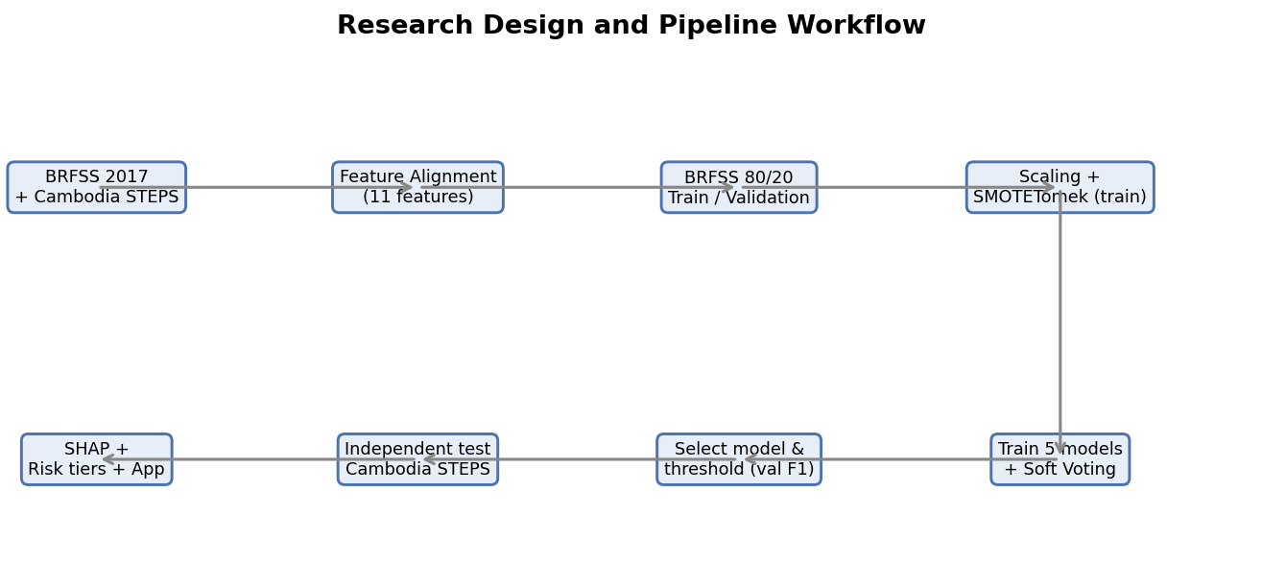
Figure 1: Research design and pipeline workflow, from data loading and feature alignment to training, ensemble selection, threshold tuning, independent testing, explainability, and the dashboard.

3.2 Tools and Technologies Used
All work was done in Python using common open-source libraries.

3.2.1 Python and Visual Studio Code
Python was used as the main language because it has many machine learning libraries and supports Jupyter notebooks, which keep the work organized and repeatable. Visual Studio Code was used as the editor for the notebooks and the application.

3.2.2 pandas, NumPy, and Matplotlib
Pandas and NumPy were used to load, align, clean, and transform the survey data. Matplotlib was used to draw the figures in this report.

3.2.3 scikit-learn
scikit-learn provided the train/validation split, the StandardScaler, the Logistic Regression and Random Forest models, the VotingClassifier used for the Soft Voting ensemble, the RandomizedSearchCV tuning, and the evaluation metrics (accuracy, precision, recall, F1-score, ROC and AUC, and the confusion matrix).

3.2.4 XGBoost, LightGBM, and CatBoost
XGBoost, LightGBM, and CatBoost are gradient boosting libraries that work well on tabular data. They were used as three of the five candidate models, and they support ways to handle class imbalance. XGBoost was also used later as the tree-based model for the SHAP analysis.

3.2.5 imbalanced-learn (SMOTETomek)
The imbalanced-learn library provided SMOTETomek, which combines SMOTE oversampling with Tomek-links cleaning. It was applied only to the training data.

3.2.6 SHAP
The SHAP library was used to explain the model. Its tree explainer computes feature contributions for tree-based models efficiently, for both overall and patient-level explanations.

3.2.7 Streamlit and the Gemini API
The pipeline was deployed as a web application using Streamlit, which shows each prediction as a patient dashboard. The Google Gemini API was used to turn the model explanation into simple lifestyle advice, with a fixed fallback message when the API is not available, so the tool still works offline.

3.3 Data Sources

3.3.1 BRFSS 2017 (Training and Validation)
The BRFSS is a large yearly health survey carried out by the United States CDC. This study uses a cleaned binary version of the 2017 survey with 275,746 records, of which 16.00% are labelled as having diabetes. Its large size and many risk-factor variables make it a good source for training.

3.3.2 Cambodia STEPS (Independent Test)
The WHO STEPS survey is a standard method used in many countries to measure non-communicable disease risk factors. In this study, the Cambodia STEPS dataset was used as the independent external test set. After data preprocessing, target preparation, missing-value handling, and alignment with the BRFSS feature schema, 873 usable records remained for the final experiment. Among these records, 751 were labelled as non-diabetes, and 122 were labelled as diabetes, giving a diabetes rate of 13.98%. This dataset was not used during training, validation, model selection, threshold tuning, scaling, or resampling. It was used only once for final independent testing.

3.4 Data Preparation and Feature Alignment
Because the two surveys were designed independently, their variables do not correspond exactly. The central preparation task was therefore to align them into a shared set of risk factors that are present in both surveys, low-cost and non-invasive, and clinically meaningful. Restricting the model to features with a genuine counterpart in each survey is what makes the cross-population comparison fair, since it ensures that the model is evaluated using the same information on which it was trained. Eleven common features remained after this step, grouped into three categories, as shown in Table 1. The target variable is Diabetes_binary, coded 1 for diabetes and 0 for no diabetes.
Group | Aligned Features
Demographic | Sex, Age, Education
Health Status | HighBP (high blood pressure), HighChol (high cholesterol), BMI
Lifestyle | Smoker, PhysActivity, Fruits, Veggies, HvyAlcoholConsump
Table 1: Aligned feature set common to BRFSS and STEPS (11 features).
Two alignment notes are important. First, age is recorded as a group from 1 to 13 in BRFSS but in actual years in STEPS, so the STEPS ages were converted into the matching BRFSS age groups. Second, income, which is in BRFSS, was dropped because it is not consistently available in STEPS. Keeping only features with a clear match in both surveys makes the transfer fair. Basic cleaning of missing values and consistent encoding was also applied so that the feature columns mean the same thing in both datasets.

3.5 Feature Engineering and Imbalance Handling

3.5.1 Standardisation
The features are on different scales, for example BMI compared with a yes/no smoking value. A StandardScaler was fit on the BRFSS training data to give each feature zero mean and unit variance, and the same scaler was then applied to the BRFSS validation set and the Cambodia STEPS test set. Fitting the scaler only on the training data prevents information from the validation or test data from leaking into the model.

3.5.2 SMOTETomek and Data Leakage
Because people with diabetes are the minority, the training data are imbalanced. SMOTETomek was used to fix this. SMOTE creates new synthetic minority examples by interpolating between real minority points, and the Tomek-links step removes pairs of opposite-class points that sit on the border, which cleans up overlapping cases.
SMOTETomek was applied only to the training set. The validation set and the Cambodia STEPS test set were kept as real, untouched data. This is important because it avoids data leakage: if synthetic data were mixed into validation or test, the results would look better than they really are and would not reflect performance on real people. By balancing only the training data, the reported validation and test numbers come from genuine cases.

3.6 Models Used
Five models were trained on the balanced BRFSS 2017 training data. The four tree-based and boosting models were tuned with RandomizedSearchCV using three-fold cross-validation and F1-score.

3.6.1 Logistic Regression
Logistic Regression is a linear model for binary classification. It is fast and easy to explain and is used here as a baseline. It was set with balanced class weights.

3.6.2 Random Forest
Random Forest is a group of decision trees trained on random samples of the data, whose results are averaged. It captures non-linear patterns and reduces overfitting compared with a single tree.

3.6.3 XGBoost
XGBoost builds trees one after another, where each new tree corrects the errors of the previous ones. It is a strong method for tabular data and can handle imbalance through weighting.

3.6.4 LightGBM
LightGBM is another gradient boosting method that grows trees leaf-wise and uses histogram-based splits, which makes it fast and memory-efficient on large datasets.

3.6.5 CatBoost
CatBoost is a gradient boosting method that is robust and works well with default settings. It was one of the three models chosen for the final ensemble.

3.7 Soft Voting Ensemble
Instead of trusting one model, the pipeline combines the strongest models. After all five models were checked on the validation set, the three best by validation F1-score, which were XGBoost, Logistic Regression, and CatBoost, were combined into a Soft Voting ensemble. Soft Voting works by averaging the predicted diabetes probabilities from the three models. The averaged probability is then compared with the chosen threshold to decide the final class. Soft Voting is useful because it balances the strengths of the different models and usually gives more stable predictions than any single model on its own.

3.8 Threshold Tuning
A model gives a probability, which must be turned into a yes/no decision using a threshold. The default of 0.50 is often not the best choice for imbalanced data. The selection rule used here is to choose the model-and-threshold pair with the highest validation F1-score among those where diabetes recall is at least 70%. This keeps recall high, which is the priority for screening, while still keeping a reasonable balance with precision. Using this rule, the Soft Voting ensemble with a threshold of 0.43 was selected as the final model.

3.9 Evaluation Metrics
Because accuracy can be misleading on imbalanced data, several metrics were used, all based on the confusion matrix.

3.9.1 Confusion Matrix
The confusion matrix shows four values: true positives (diabetes correctly found), true negatives (no diabetes correctly cleared), false positives (no diabetes wrongly flagged, a Type I error), and false negatives (diabetes wrongly cleared, a Type II error). In screening, false negatives are the most harmful, which is why recall is the priority.
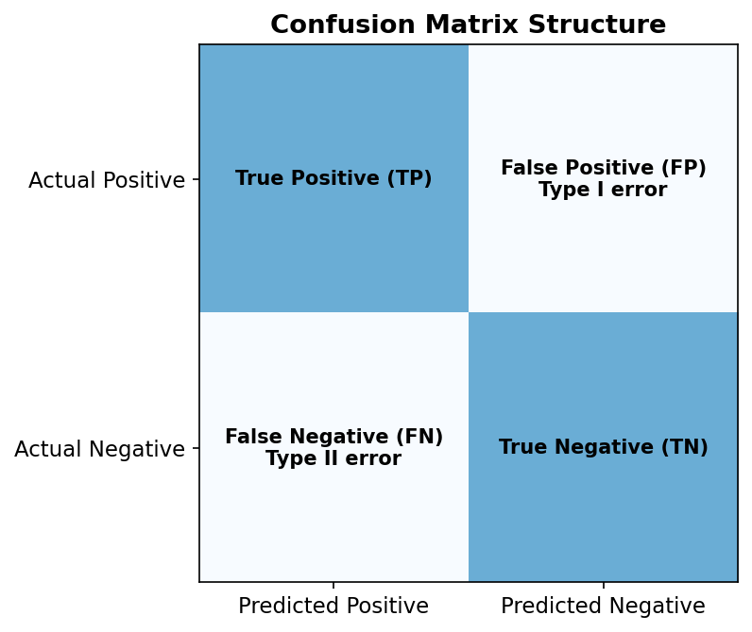
Figure 2: The structure of a confusion matrix, showing true positives, true negatives, false positives, and false negatives.

3.9.2 Accuracy, Precision, Recall, and F1-Score
Accuracy is the share of all predictions that are correct. Precision is the share of flagged people who really have diabetes. Recall is the share of real diabetes cases that the model finds, and it is the main clinical priority here. F1-score is the harmonic mean of precision and recall and balances the two, and it is the main metric used for model selection.

3.9.3 ROC Curve and AUC
The ROC curve plots the true positive rate against the false positive rate as the threshold changes, and the AUC (Area Under the Curve) summarises how well the model separates the two classes across all thresholds. An AUC of 1.0 is perfect and 0.5 is random guessing.
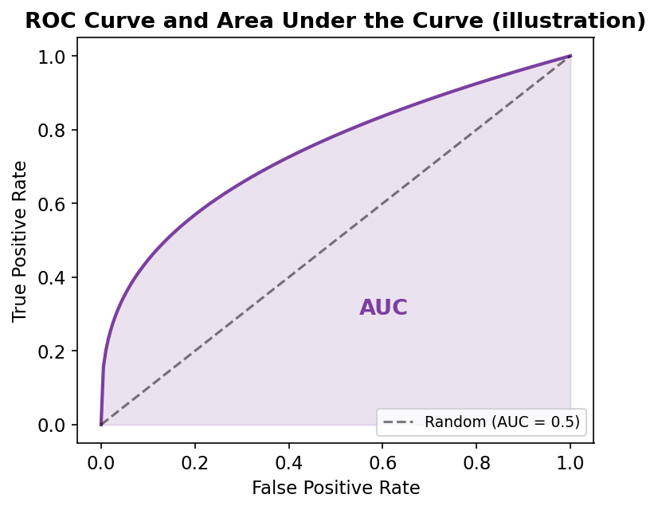
Figure 3: Illustration of an ROC curve and the area under the curve (AUC).

3.10 Explainability Method
Explainability is treated as part of the method, not an extra step. After the final model is selected, SHAP is used on the Cambodia STEPS test set. SHAP gives each feature a value showing how much it increased or decreased the predicted risk, for each person. The absolute SHAP values can be averaged over all patients to give an overall importance ranking, while the values for one patient explain a single prediction.
One point must be made clearly. The final model is a Soft Voting ensemble, so a tree-based SHAP explainer cannot explain the full ensemble exactly. For this reason, XGBoost was used as a tree-based proxy model for SHAP. This choice is reasonable because XGBoost was the strongest individual tree-based model by validation F1-score, it is one of the three models inside the Soft Voting ensemble, and TreeSHAP is efficient and well suited to tree-based models. The SHAP results therefore explain the strongest tree-based part of the ensemble and help us understand the model’s behaviour, but they are not a perfect explanation of the full Soft Voting model.
Finally, the predicted probabilities are grouped into three risk tiers, Low, Moderate, and High, to make the result easier to read in the dashboard. The meaning of these tiers is explained carefully in Section 4.7.

CHAPTER 4
RESULTS

4.1 Experimental Setup
All experiments were run on a personal laptop using the Python tools described in Chapter 3, inside Jupyter notebooks. A fixed random seed of 42 was used for the data split, the resampling, the model setup, and the hyperparameter search, so that the whole pipeline can be reproduced. Hyperparameters were tuned with RandomizedSearchCV using three-fold cross-validation and F1-score.

4.2 Data Distribution
The two surveys differ in size and slightly in diabetes rate. BRFSS 2017 has 275,746 records with a 16.00% diabetes rate, while Cambodia STEPS has 873 usable records after preprocessing and feature alignment, with a 13.98% diabetes rate. Figure 4 compares the two class distributions.
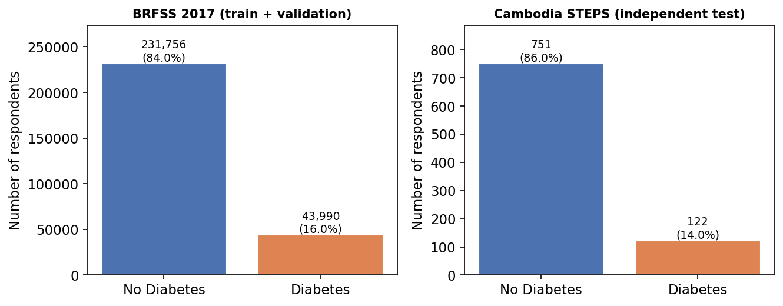
Figure 4: Class distribution of BRFSS 2017 (training source) and Cambodia STEPS (independent test).
The figure shows that both datasets are imbalanced, with far more non-diabetes cases than diabetes cases. The diabetes rate is close in the two experimental datasets (16.0% versus 13.98%), but the BRFSS dataset is much larger, which is why it is used for training.

4.3 Data Splits
The BRFSS 2017 data were split into 80% for training and 20% for validation using stratified sampling, so the diabetes rate stays the same in both parts. The whole Cambodia STEPS dataset was kept as the test set. Table 2 and Figure 5 show the sizes and class balance of each split.

Split | Total Records | No Diabetes | Diabetes | Diabetes Rate
Train — BRFSS 2017 (80%) | 220,596 | 185,404 | 35,192 | 15.95%
Validation — BRFSS 2017 (20%) | 55,150 | 46,352 | 8,798 | 15.95%
Test — Cambodia STEPS | 873 | 751 | 122 | 13.98%
Table 2: Class distribution per data split. Cambodia STEPS contains 873 usable records after preprocessing and feature alignment and is used only for the final test.
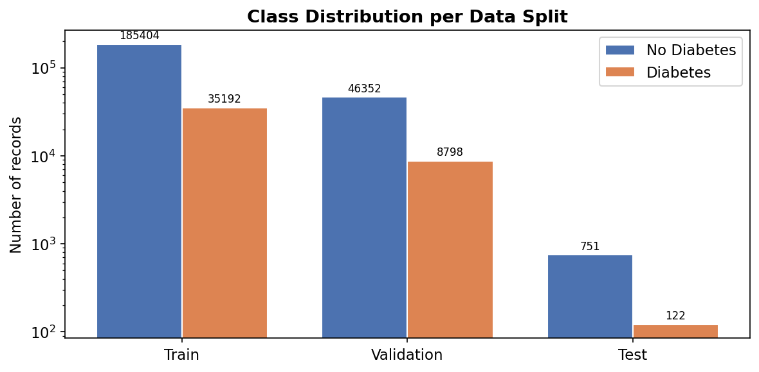
Figure 5: Class distribution across the training, validation, and test splits (log scale, because BRFSS is much larger than STEPS).
Table 2 confirms that the training and validation sets keep almost the same diabetes rate (about 16%), which is the effect of stratified splitting. The Cambodia STEPS test set is much smaller and comes from a different population, which is the main challenge of this study.

4.4 Class Balancing with SMOTETomek
SMOTETomek was applied to the training set only, to balance the two classes before training. Table 3 and Figure 6 show the class counts before and after balancing.
Training Set | No Diabetes | Diabetes
Before SMOTETomek | 185,404 | 35,192
After SMOTETomek | 182,354 | 182,354
Table 3: Training-set class counts before and after SMOTETomek (validation and test untouched).
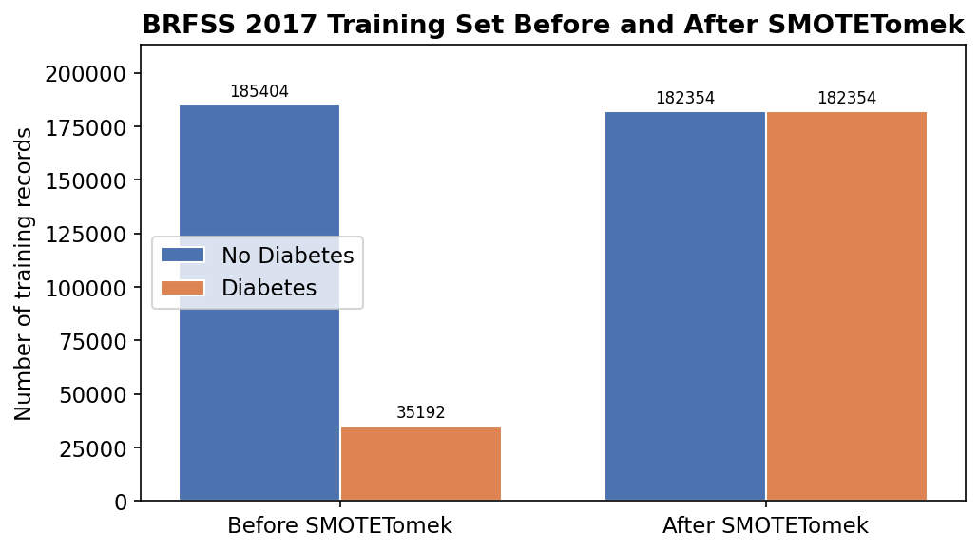
Figure 6: BRFSS 2017 training set before and after SMOTETomek balancing.
After SMOTETomek, the two classes in the training set are equal, with 182,354 records each. This helps the models learn the minority diabetes class better. The validation and test sets were not changed, so the results reported later come from real cases and are not affected by synthetic data.

4.5 Validation Results of Individual Models
The five models were checked on the BRFSS 2017 validation set using a default threshold of 0.50. Table 4 reports accuracy, precision, recall, and F1-score for each model, and Figure 7 shows the same results as a bar chart.
Model | Accuracy | Precision | Recall | F1-score
XGBoost | 77.45% | 37.07% | 59.24% | 45.60%
Logistic Regression | 70.44% | 31.79% | 74.45% | 44.55%
CatBoost | 80.08% | 40.04% | 49.99% | 44.46%
Random Forest | 78.50% | 35.48% | 42.49% | 38.67%
LightGBM | 80.41% | 38.49% | 38.12% | 38.31%
Table 4: Individual model performance on the BRFSS 2017 validation set (threshold 0.50).
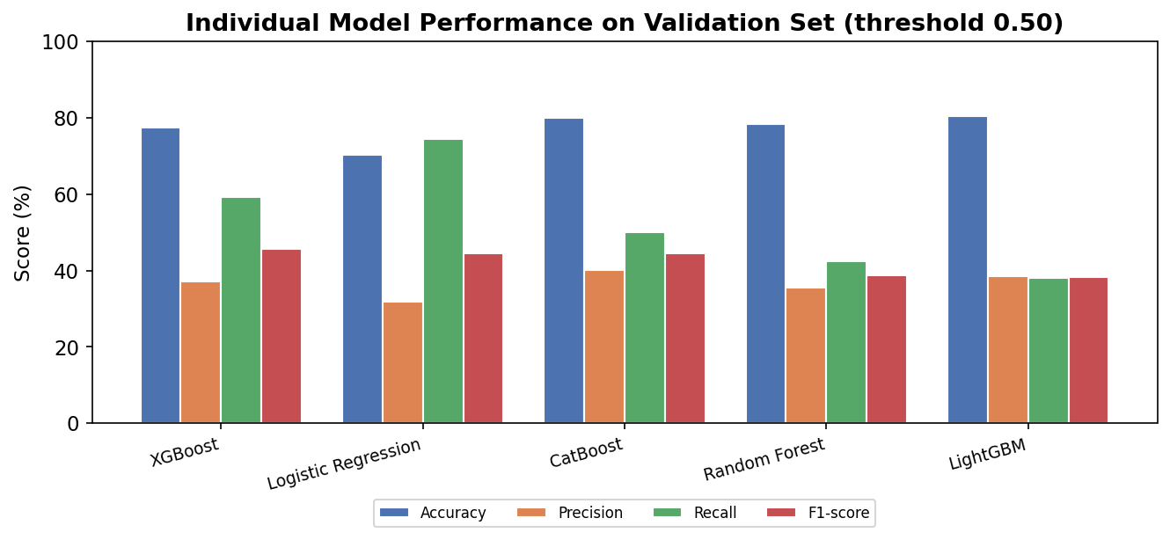
Figure 7: Comparison of the five models on the validation set (threshold 0.50).
The results reveal a clear trade-off between recall and precision. Logistic Regression attains the highest recall (74.45%) but lower precision, because as a linear model with balanced class weights it flags risk generously. LightGBM and CatBoost achieve higher accuracy but lower recall, as boosting models tend to lean toward the majority class on imbalanced data. XGBoost yields the best F1-score (45.60%), striking the most favourable balance between recall and precision. On the basis of validation F1-score, the three strongest models, XGBoost, Logistic Regression, and CatBoost, were selected for the Soft Voting ensemble; combining a linear model with two boosting models was expected to blend complementary decision boundaries and improve stability.

4.6 Final Model and Threshold Selection
The three best models were combined into a Soft Voting ensemble. The final model and threshold were chosen using the rule of highest validation F1-score among options where diabetes recall is at least 70%. This rule selected the Soft Voting ensemble with a threshold of 0.43. Table 5 shows the validation results of the selected model.
Metric | Soft Voting ensemble (Validation, threshold 0.43)
Recall (clinical priority) | 70.46%
F1-score (selection metric) | 45.15%
Accuracy | 72.69%
Precision | 33.22%
Table 5: Validation performance of the selected Soft Voting ensemble at threshold 0.43.
At threshold 0.43, the Soft Voting ensemble reaches a validation recall of 70.46%, which meets the recall requirement, with an F1-score of 45.15%. The accuracy is 72.69% and the precision is 33.22%. The lower threshold (0.43 instead of 0.50) makes the model flag more people as at risk, which raises recall at the cost of precision. This is the correct trade-off for a screening tool.
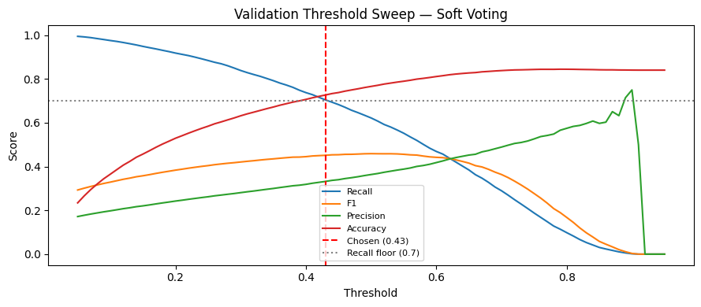
Figure 8: Threshold tuning result on the validation set, showing how recall, precision, F1-score, and accuracy change with the threshold, with the chosen threshold of 0.43 marked.

4.7 Risk Tiers and the Classification Threshold
It is important to separate two different things: the classification threshold and the risk tiers. The classification threshold is the value used to make the yes/no decision. In this study the final threshold is 0.43. If the predicted probability is 0.43 or higher, the person is classified as diabetes risk; if it is below 0.43, the person is classified as no diabetes risk.
The risk tiers are different. They are only a way to communicate the probability level in the dashboard, so the result is easier to understand. The tiers are based on the predicted probabilities from the Soft Voting model on Cambodia STEPS, using these ranges: Low risk is a predicted probability below 30%, Moderate risk is from 30% up to below 70%, and High risk is 70% or above.
These tiers are model-based communication categories. They are not official medical diagnostic cut-offs and should not be presented as clinically validated thresholds. They simply help a reader see whether a predicted probability is low, medium, or high. Table 6 and Figure 9 show how the Cambodia STEPS respondents fall into the three tiers.
Risk Tier | Predicted Probability | STEPS Respondents
Low | below 30% | 299
Moderate | 30% to below 70% | 401
High | 70% or above | 173
Table 6: Risk-tier distribution of the Cambodia STEPS respondents under the Soft Voting model.
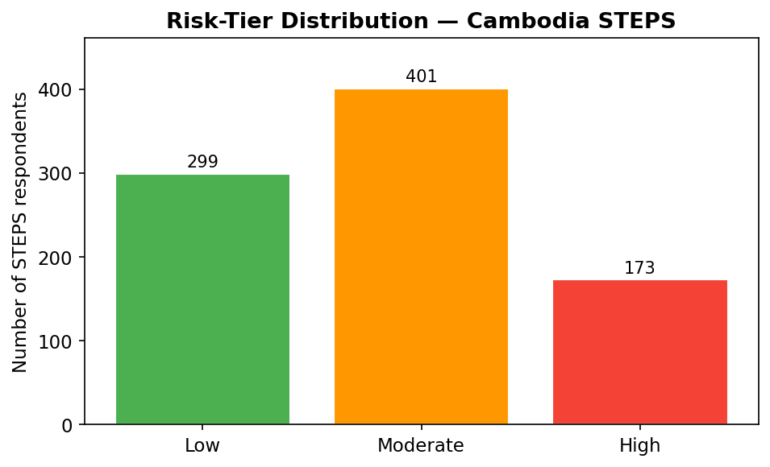
Figure 9: Risk-tier distribution for the Cambodia STEPS test set.
Most respondents fall into the Low and Moderate tiers, with 173 in the High tier. These tiers are only for communication and interpretation; the actual classification still uses the 0.43 threshold described above.

4.8 Independent Test on Cambodia STEPS
The selected Soft Voting model and the 0.43 threshold were then applied, for the first time, to the Cambodia STEPS test set. This data had no part in training, validation, or selection, so it gives an honest measure of how the model transfers to a new population. Table 7 reports the results.
Metric | Cambodia STEPS (independent test)
Recall (clinical priority) | 76.23%
F1-score | 32.40%
Accuracy | 55.56%
Precision | 20.58%
Table 7: Independent test results on Cambodia STEPS (Soft Voting ensemble, threshold 0.43).
The most important result is recall. At 76.23%, the model correctly found most of the real diabetes cases in a population it had never seen, which is what a screening tool needs to do. At the same time, accuracy (55.56%) and precision (20.58%) were lower than on validation, and the F1-score dropped to 32.40%. In simple terms, the model flags many people to make sure it does not miss real cases, but this also produces many false alarms when it is used on a different population.
Figure 10 shows the confusion matrix on Cambodia STEPS. Out of 122 real diabetes cases, the model correctly found 93 and missed 29. Out of 751 non-diabetes cases, it correctly cleared 392 but wrongly flagged 359. This matches the pattern of high recall and low precision.
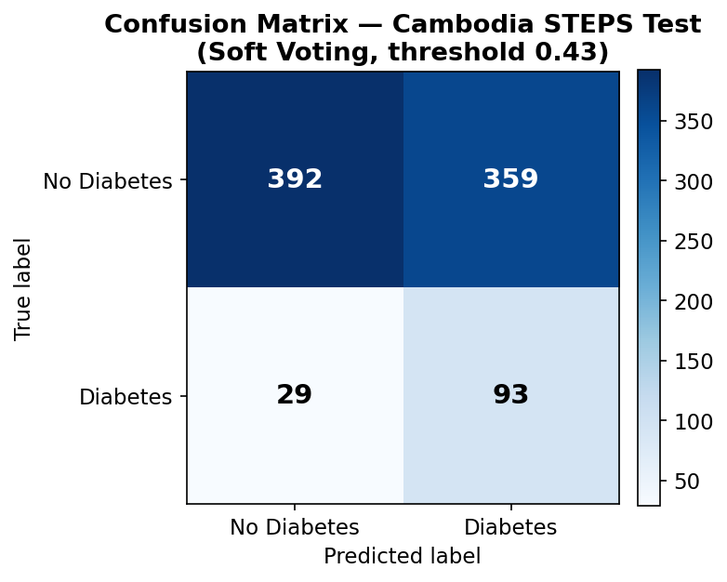
Figure 10: Confusion matrix on the Cambodia STEPS test set (Soft Voting, threshold 0.43).

4.9 Validation vs Test Comparison
Table 8 and Figure 11 compare the validation and test results of the Soft Voting model side by side, which shows the cross-population gap clearly.
Metric | Validation (BRFSS 2017) | Test (Cambodia STEPS)
Recall | 70.46% | 76.23%
F1-score | 45.15% | 32.40%
Accuracy | 72.69% | 55.56%
Precision | 33.22% | 20.58%
Table 8: Validation versus independent-test results for the Soft Voting ensemble.
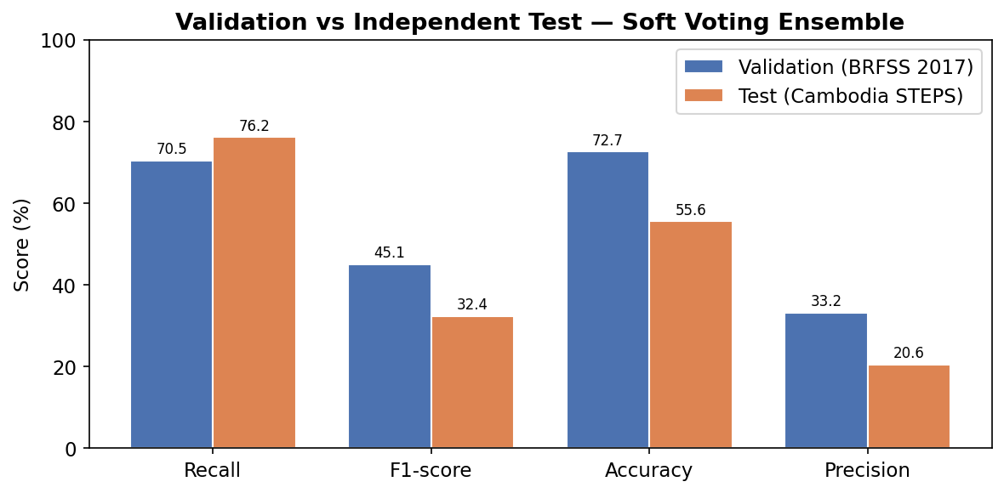
Figure 11: Validation versus Cambodia STEPS test results for the Soft Voting ensemble.
Recall actually increased slightly from validation (70.46%) to test (76.23%), because the low decision threshold continues to flag a large share of cases even under distribution shift. Accuracy and precision, however, fell markedly on the Cambodian data. This pattern is the signature of cross-population domain shift: the statistical relationship between the risk factors and diabetes in Cambodia differs from the one the model learned from United States data, so the same probability cut-off that balanced precision and recall on BRFSS produces many false positives on STEPS. This is an honest and expected outcome when transferring a model between substantially different populations, and it is precisely the effect that single-population evaluations cannot expose.

4.10 Explainability Results
SHAP was used on the Cambodia STEPS predictions, with XGBoost as the tree-based proxy model explained in Section 3.10. Figure 12 shows the overall feature importance, based on the average absolute SHAP values, and Figure 13 shows a local explanation for one patient. In line with medical knowledge and earlier studies, the strongest factors were body mass index, high blood pressure, high cholesterol, and age, while lifestyle factors such as physical activity and fruit and vegetable intake tended to lower the predicted risk.
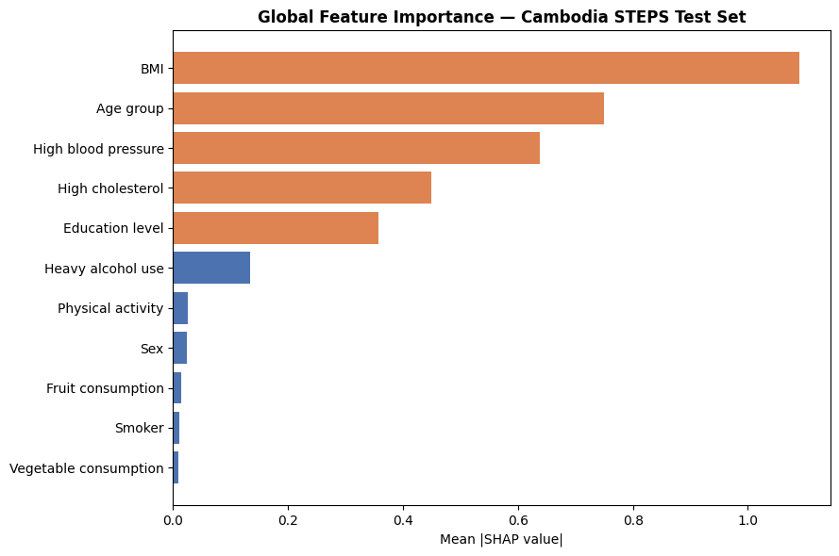
Figure 12: SHAP global feature importance (mean absolute SHAP value) on the Cambodia STEPS test set, using XGBoost as the tree-based proxy model.
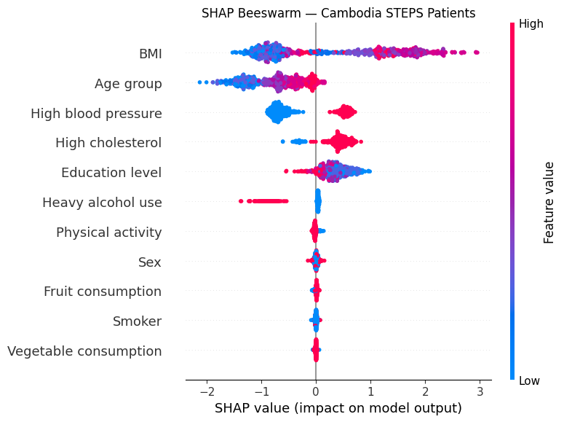
Figure 13: SHAP local explanation for a single Cambodia STEPS patient, showing which features increased or decreased the predicted risk.
These explanations are useful in two ways. Overall, they show that the model relies on sensible health factors and not on strange patterns, which helps build trust. For a single patient, they give a short and clear reason for the prediction, which is the basis of the dashboard. As noted before, these SHAP results explain the strongest tree-based part of the ensemble, not the full Soft Voting model exactly.
Figure 14: Distribution of predicted probabilities on Cambodia STEPS, separated by true class, with the 30% and 70% tier cut-offs marked.

4.11 Patient Dashboard and Actionable Insights
The final model is shown to the user through a Streamlit dashboard. For each person, the dashboard shows the predicted probability and risk tier, the main SHAP reasons colored by whether they raise or lower risk, the contribution of the demographic, health-status, and lifestyle groups, and simple lifestyle advice generated through the Gemini API with a safe offline fallback. The application can also accept a CSV file to screen many people at once. This turns a single number into an explanation and a set of actionable insights that a non-expert can understand.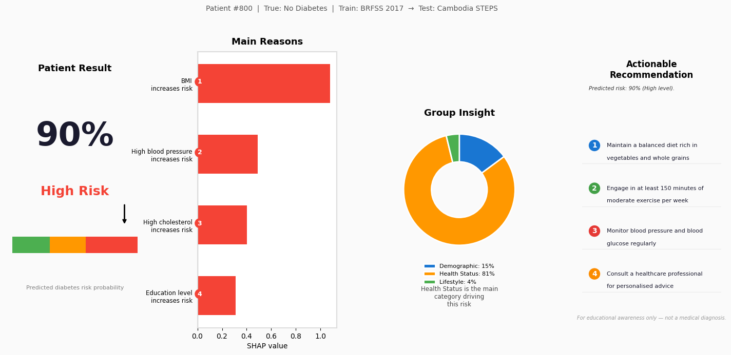
Figure 15: Patient dashboard from the deployed application, showing the risk gauge, the main SHAP reasons, the group contributions, and the lifestyle advice.
It is important to repeat that the dashboard is a screening support tool, not a medical diagnosis system. A High risk result is a reason to do a proper medical test, not a confirmed diagnosis.

CHAPTER 5
DISCUSSION

5.1 Overview
This chapter explains what the results mean for diabetes screening in Cambodia. It looks at how well the models worked, the cross-population gap, the value of explainability and the dashboard, and the main challenges of the study.

5.2 Effectiveness of the Models
On the validation data, the approach worked as expected. The tree-based and boosting models performed well, and the Soft Voting ensemble combined the strengths of XGBoost, Logistic Regression, and CatBoost. Choosing the model and threshold by validation F1-score with a recall requirement made sure the final model fits the needs of screening rather than just chasing accuracy.
The decision to prioritise recall was the single most consequential design choice. Had the project optimised for accuracy, it could have reported a higher headline figure by favouring the majority “no diabetes” class, but the resulting tool would have missed many genuine cases. By holding recall high, the model errs on the side of caution, which is the safer posture for screening. The price is lower precision and more false alarms; however, a false alarm leads only to an additional confirmatory test, whereas a missed case can result in untreated disease and severe complications.

5.3 The Cross-Population Gap
The clearest finding is the gap between validation and independent-test performance. On the BRFSS validation data the model performed reasonably, but when it was applied to Cambodia STEPS its accuracy and precision fell while recall remained high. This is the hallmark of domain shift, and it is precisely the behaviour that single-population studies cannot reveal, because they evaluate on data drawn from the same distribution as the training set.
Several factors plausibly contribute to this gap. The association between body mass index and diabetes risk is known to differ between Western and Asian populations, so a relationship learned from United States data may not fit Cambodia well. Differences in diet, physical activity, and the phrasing of survey questions mean that even aligned features are not perfectly equivalent across the two datasets. Moreover, the eleven common features, although necessary for a fair transfer, omit information that a fully local model could exploit.
The honest interpretation is not that the model failed, but that transferring a diabetes model from one population to a substantially different one is intrinsically difficult. A transferred model of this kind should be regarded as a high-recall, first-pass screening tool whose positive results require local confirmation, rather than as a diagnostic system.

5.4 Value of Explainability and the Dashboard
Despite its limitations as a predictor, the system has practical value because it is interpretable and deployable. The SHAP analysis showed that the model relies on clinically sensible factors such as body mass index, blood pressure, cholesterol, and age, which is important for trust. Patient-level explanations translate a probability into a concise reason, and the accompanying lifestyle advice translates that reason into action. The dashboard presents all of this in a form accessible to non-experts, and its batch mode supports screening many people at once. In a setting where trust and clarity matter as much as raw accuracy, these are meaningful capabilities rather than mere add-ons. Using XGBoost as a transparent proxy for SHAP, rather than claiming an exact explanation of the ensemble, keeps the interpretation honest.

5.5 Challenges and Findings
Several challenges shaped this work. The main one was data: the lack of a large local labelled dataset is the reason transfer learning was needed, and the small size of the Cambodia STEPS test set, with 873 usable records after preprocessing and feature alignment, limits how precise the external test results can be. Aligning two different surveys into a fair common set needed careful choices, such as the age-group mapping and dropping income. Class imbalance needed careful handling with SMOTETomek and threshold tuning, applied only to the training data to avoid leakage. Balancing performance with explainability and ease of use was also a constant concern.
The main findings are clear. Tree-based and boosting models, combined by Soft Voting, are a good fit for this tabular task. A recall-focused threshold is essential for screening and changes how the model behaves. Cross-population transfer has a real cost that single-population studies hide, and reporting this honestly is more useful than an inflated accuracy claim. And explainability is what makes the tool trustworthy and usable in practice.

5.6 Threats to Validity
As with any empirical study, the validity of these findings is subject to several threats, discussed here under the standard categories of internal, external, and construct validity.
Internal validity concerns whether the reported results genuinely follow from the methodology rather than from artefacts of the experimental setup. This risk was mitigated by fitting the scaler and applying SMOTETomek only on the training data, by using a fixed random seed for reproducibility, and by tuning hyperparameters with cross-validation. The main residual threat is threshold dependency: the reported operating point depends on the 0.43 threshold selected on the validation set, and a different threshold would shift the balance between recall and precision. Because the threshold was chosen before the STEPS data were examined, however, the independent test remains unbiased.
External validity concerns the extent to which the findings generalise beyond the specific data used. The most significant threat is population bias: the model was trained on a United States survey and tested on a Cambodian one, and the two populations differ in diet, body composition, healthcare access, and disease awareness. In addition, the Cambodia STEPS test set is relatively small (873 records), so its performance estimates carry a degree of sampling uncertainty. These factors limit the extent to which the results can be extrapolated to the wider Cambodian population or to other settings.
Construct validity concerns whether the measured variables truly represent the intended concepts. Because the two surveys were designed independently, aligned features are not perfectly equivalent: for example, age was recorded in years in STEPS but in grouped bands in BRFSS and had to be mapped between the two, and self-reported behavioural variables such as diet and physical activity may be interpreted differently across cultures and survey instruments. The binary diabetes label likewise reflects each survey's own definition. These feature-alignment and measurement limitations mean that even carefully harmonised features may capture slightly different constructs in the two datasets.
Finally, both surveys rely on self-reported data and share the class imbalance typical of diabetes datasets. Self-report can introduce recall and social-desirability bias, and the minority diabetes class was balanced only in training through synthetic oversampling, which, although confined to the training data, may not perfectly reflect the true minority distribution. These considerations should be borne in mind when interpreting the reported metrics.

5.7 Ethical Considerations
Because this work concerns health data and a tool that could influence health-related decisions, several ethical considerations were taken into account.
The study uses only publicly available, de-identified secondary datasets. The BRFSS data are released for public use by the United States CDC, and the Cambodia STEPS data were obtained for academic research; no individual is identifiable, and no new personal data were collected. This minimises privacy risk while still enabling a realistic evaluation.
The system is explicitly designed as a screening-support tool and not as a diagnostic device. Every output is framed as a risk estimate that must be confirmed by a qualified clinician through appropriate laboratory testing. Maintaining human oversight in this way guards against over-reliance on the model and ensures that clinical judgement remains central; a high-risk result should prompt further testing, never a self-directed treatment decision.
As with any risk-prediction tool, there is potential for misuse, for example, using a risk score to deny insurance or employment, or presenting the tool as a substitute for professional care. Such uses would be inappropriate and lie explicitly outside the intended scope of this work. The relatively high false-positive rate also means that positive results must be communicated carefully to avoid causing unnecessary anxiety.
Fairness is a further concern, since a model trained on one population may perform unevenly across subgroups defined by sex, age, or socioeconomic status. While a full fairness audit is left to future work, the interpretability provided by SHAP contributes to transparency by exposing the factors that drive each prediction, which supports the responsible and accountable use of the system.

CHAPTER 6
CONCLUSION

6.1 Summary of Findings
This study developed and independently evaluated a machine learning system for diabetes risk prediction in Cambodia, using a model trained on the large United States BRFSS 2017 survey and tested once on the independent Cambodia STEPS dataset. Eleven common, non-invasive risk factors were aligned into a shared feature set; the training data were scaled and balanced with SMOTETomek; five machine learning models were developed and compared; and the three strongest, XGBoost, Logistic Regression, and CatBoost, were combined into a Soft Voting ensemble. The final model and its decision threshold were selected by validation F1-score while keeping recall at or above 70%.
On the Cambodia STEPS test set, the selected ensemble, at a threshold of 0.43, achieved a recall of 76.23%, correctly identifying most of the true diabetes cases in a population it had never seen. Accuracy (55.56%) and precision (20.58%) were lower on the Cambodian data, honestly reflecting the inherent difficulty of cross-population transfer rather than a defect of the method. To support interpretation, SHAP, with XGBoost as a tree-based proxy, confirmed that the model relies on clinically sensible factors and enabled clear patient-level explanations, which were presented together with risk tiers and lifestyle advice in a dashboard.
The principal contribution of this study is a transparently benchmarked, recall-oriented machine learning system for cross-population diabetes risk prediction in a low-resource setting, complemented by model interpretation and a working, deployable tool that delivers actionable insights. The central message is that such a transferred, recall-focused prediction model can serve as a valuable early-awareness and research instrument, but it cannot replace medical diagnosis, and its positive predictions should always be confirmed by appropriate clinical testing.

6.2 Future Work
Several directions could build on this study. The most impactful is to collect local, clinically confirmed Cambodian data; even a moderate labelled sample would allow the model to be retrained or fine-tuned for the local population, which the present results suggest would improve precision and calibration.
• Domain adaptation and transfer learning: apply domain-adaptation and transfer-learning techniques, such as fine-tuning on a small local sample, to reduce the cross-population gap between BRFSS and Cambodia.
• Probability calibration: calibrate the predicted probabilities so that the risk tiers correspond more closely to the true probabilities in the Cambodian population.
• Richer features: incorporate additional locally relevant predictors that were omitted from the common set, such as waist circumference, sedentary time, family history, and more detailed dietary information, where these can be collected reliably.
• Fairness analysis: conduct a systematic fairness audit across sex, age, and socioeconomic groups to ensure that the model performs equitably.
• Federated learning: explore federated learning so that multiple clinics can jointly improve the model without sharing raw patient data, thereby preserving privacy.
• Prospective and multi-country validation: validate the model prospectively in real screening settings and across multiple countries to establish broader generalisability.
• Clinical validation and system integration: pursue formal clinical validation and integrate the tool into existing healthcare and community-health workflows, moving toward real-time and offline deployment.
Taken together, these steps would move the system from an honest research benchmark toward a locally validated, fair, and clinically integrated screening-support tool that could meaningfully assist early diabetes awareness in Cambodia.

REFERENCES
[1] Z. Xie, O. Nikolayeva, J. Luo, and D. Li, “Building risk prediction models for type 2 diabetes using machine learning techniques,” Preventing Chronic Disease, vol. 16, p. E130, 2019. doi: 10.5888/pcd16.190109.
[2] P. B. Khokhar, V. Pentangelo, F. Palomba, and C. Gravino, “Towards transparent and accurate diabetes prediction using machine learning and explainable artificial intelligence,” arXiv preprint arXiv:2501.18071, 2025. doi: 10.48550/arXiv.2501.18071.
[3] P. B. Khokhar, C. Gravino, and F. Palomba, “Advances in artificial intelligence for diabetes prediction: Insights from a systematic literature review,” Artificial Intelligence in Medicine, vol. 164, p. 103132, 2025. doi: 10.1016/j.artmed.2025.103132.
[4] M. Li, A. Tan, L. Song, X. Qiu, L. Zhou, and Z. Wen, “Performance of diabetes risk prediction models: A systematic review and meta-analysis,” Endocrine Connections, vol. 14, no. 11, p. e250353, 2025.
[5] Centers for Disease Control and Prevention, “2017 BRFSS survey data and documentation,” 2017.
[6] World Health Organization, “STEPwise approach to NCD risk factor surveillance (STEPS),” World Health Organization.
[7] T. Chen and C. Guestrin, “XGBoost: A scalable tree boosting system,” in Proceedings of the 22nd ACM SIGKDD International Conference on Knowledge Discovery and Data Mining, 2016, pp. 785–794. doi: 10.1145/2939672.2939785.
[8] G. Ke et al., “LightGBM: A highly efficient gradient boosting decision tree,” Advances in Neural Information Processing Systems, vol. 30, 2017.
[9] L. Prokhorenkova, G. Gusev, A. Vorobev, A. V. Dorogush, and A. Gulin, “CatBoost: Unbiased boosting with categorical features,” Advances in Neural Information Processing Systems, vol. 31, 2018.
[10] L. Breiman, “Random forests,” Machine Learning, vol. 45, no. 1, pp. 5–32, 2001. doi: 10.1023/A:1010933404324.
[11] S. M. Lundberg and S.-I. Lee, “A unified approach to interpreting model predictions,” Advances in Neural Information Processing Systems, vol. 30, pp. 4765–4774, 2017.
[12] N. V. Chawla, K. W. Bowyer, L. O. Hall, and W. P. Kegelmeyer, “SMOTE: Synthetic minority over-sampling technique,” Journal of Artificial Intelligence Research, vol. 16, pp. 321–357, 2002.
[13] F. Pedregosa et al., “Scikit-learn: Machine learning in Python,” Journal of Machine Learning Research, vol. 12, pp. 2825–2830, 2011.
[14] G. Lemaître, F. Nogueira, and C. K. Aridas, “Imbalanced-learn: A Python toolbox to tackle the curse of imbalanced datasets in machine learning,” Journal of Machine Learning Research, vol. 18, no. 17, pp. 1–5, 2017.
[15] International Diabetes Federation, IDF Diabetes Atlas, 10th ed. Brussels, Belgium: International Diabetes Federation, 2021.

APPENDICES

Appendix A: Deployed Application
The diabetes risk-screening prototype was implemented using Streamlit. The application allows a user to enter individual health information or upload a CSV file for batch prediction. The dashboard displays the predicted diabetes risk probability, risk tier, main SHAP-based explanation factors, grouped feature contributions, and lifestyle recommendations. A screenshot of the application interface is included in Figure 15.

Appendix B: Source Code and Notebooks
The complete source code includes the final training notebook train_2017_v2.ipynb, the data-preparation files, saved model files, scaler file, threshold file, feature-name file, and the Streamlit application file app.py. These files are used to reproduce the final experiment and run the deployed prototype.

Appendix C: Reproducibility
All experiments used a fixed random seed of 42. The BRFSS 2017 dataset was split into 80% training and 20% validation using stratified sampling. SMOTETomek was applied only to the training set. The Cambodia STEPS dataset was used only once as the independent test set. The final Soft Voting ensemble, scaler, selected threshold of 0.43, and aligned feature list were saved and loaded directly by the application, ensuring that the model used in the dashboard matches the model evaluated in this report.

